**Hong Kong Institute of Vocational Education (Tsing Yi)**

**Department of Information Technology**

**Higher Diploma in Software Engineering**

**ITP4506 HCI & GUI Programming**

Project Phase II Documentation Assignment

**(2022/2023)**

We declare that this is a group project and that no part of this submission has been copied from any other student’s work or from any other source except where due acknowledgement is made explicitly in the text, nor has any part been written for us by another person.

|  |  |  |
| --- | --- | --- |
| **Student** | **Contribution to the project (%)**  **(Total 100%)** | **Signature** |
| Chan Kei Sum | 50% |  |
| Chan Wai Kuen | 50% |  |

1. **User Analysis**

1.User Characteristics

2.Techniques for observing and listening to users

3.Environment Analysis

4.Recruiting Users

5.Task Analysis(HTA)

1. **Web Design Concepts**

1. User Characteristics

1.1. Customer who buy air tickets

Learning style

**Operator:**

Because the design of our website is very simple, and there will be notes and instructions in every operation place, so the operator can save the time of looking at the webpage manual, and at the same time, the functions are not very diverse, so only need to know a few operation steps, You can fully control the system.

**Normal User:**

Ordinary users often use the air ticket booking system, because users will log in to different air ticket booking systems for comparison, and the operations of different computer air ticket booking systems are similar, so most users understand the basic air ticket booking functions, and our web design is very simple, even if there are no certain functions, there will be guidelines and notes.

Tool preferences

Mouse or keyboard as the project will only be desktop compatible, it is assumed that the user will use a PC desktop. For desktop input tools, the user group are experienced in using mouse and keyboard as input tools. c. Physical differences

Physical differences

Different people's abilities may vary, but this site is for adults. So ages around 18-50. Furthermore, the target groups are men and women.

In addition, due to visual limitations such as color blindness, this site

Will set the primary colors of green, white and gray. font size is not too big

Big and too small. The title is set to 30px. The content can be set to 15-20px.

|  |  |
| --- | --- |
| Font size of title | 30px |
| Font size of content | 15-20px |
| Main color of website | White, Grey, Blue |

Cultural differences

The target customers are Hong Kong people with a Basic English level. also,

Reading levels are also higher. For sites that use vocabulary, users can also

To understand the meaning, they don't need to look up the dictionary. website language Can use English

Knowledge of job

Some basic daily English expressions, such as air tickets, destinations and names of departure places.

Application familiarity

A user can be a novice or an expert in the ticketing system. Since many platforms provide online ticket booking, users may have experience in using such applications, they can understand the operation process, and have the knowledge to diagnose problems in the operation process. On the other hand, the user May only have the concept of an online ticket system, they may not have performed the operation before. It is found that the website interface design should be similar to other online ticket booking sites so that users can identify the service process

Primary and secondary users

|  |  |
| --- | --- |
| Primary User | Secondary User |
| Operator | Normal user |
| Admin |  |

Techniques for observing and listening to users

Online survey:

Because our system is an air ticket reservation system, if our system needs to accept opinions, we will collect opinions through online Q&A.

Environment Analysis

Our main target customers will buy air tickets at home, so we need to set the color not too bright or too dark, and we should provide a comfortable user interface for customers. The website has enough areas to show the information since the user's computer screen is large. Additionally, we can provide scrolling to move the webpage.

Recruiting Users

Since our system is to help the original airlines do computerized work, we can call the original customers to test our system, as a result, we will give them discount codes to make them cheaper when buying air tickets. For this For the system, the user's opinion is very important, he is our system can be improved and the system's errors and omissions can be repaired.

5. Task Analysis

Normal user(Customer):

* Register
* Login
* Search flight information
* Make Booking
* Make Payment
* View Attraction
* View Ticket
* Change Ticket Content

Admin:

**Main Task**

* Add new Account
* Send Email Request
* Delete Account

Operator

**Main Task**

* Search & Edit Airline
* View Customer Ticket Request
* Accept Refund Request
* Reject The Request

**Normal user**

Register

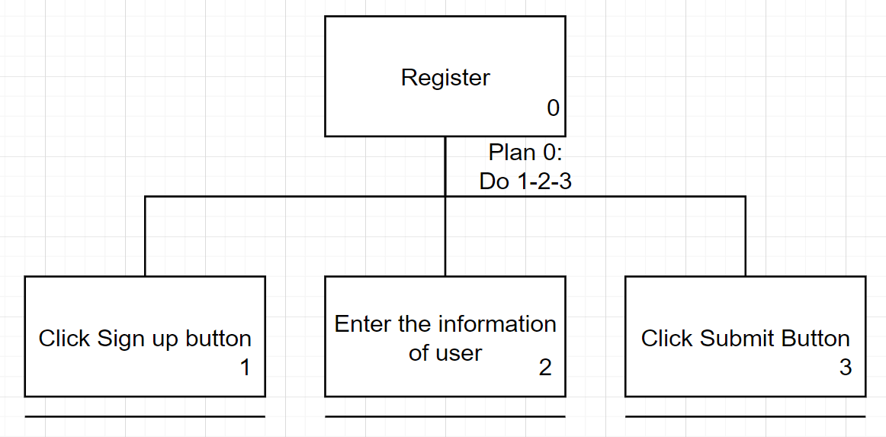

Login

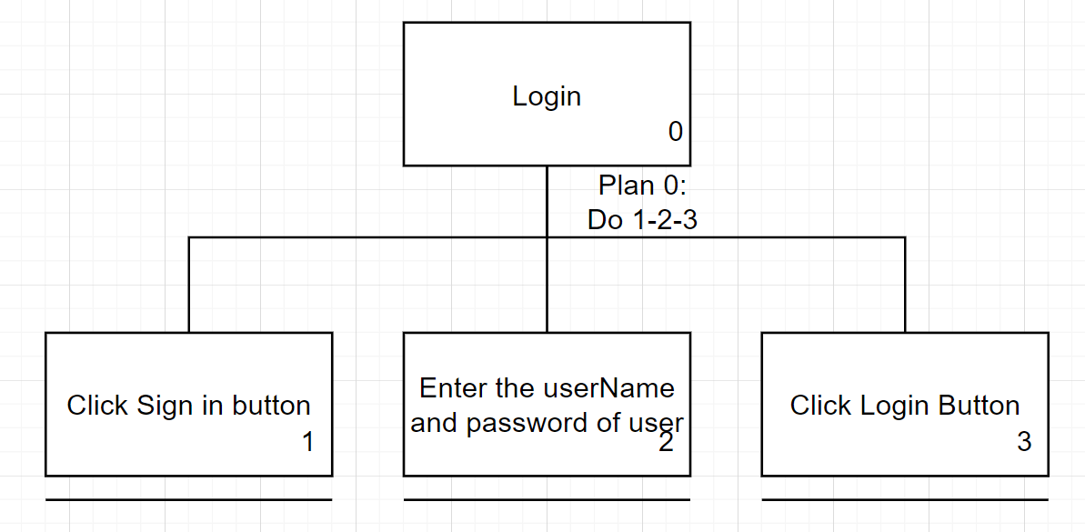

Search flight information

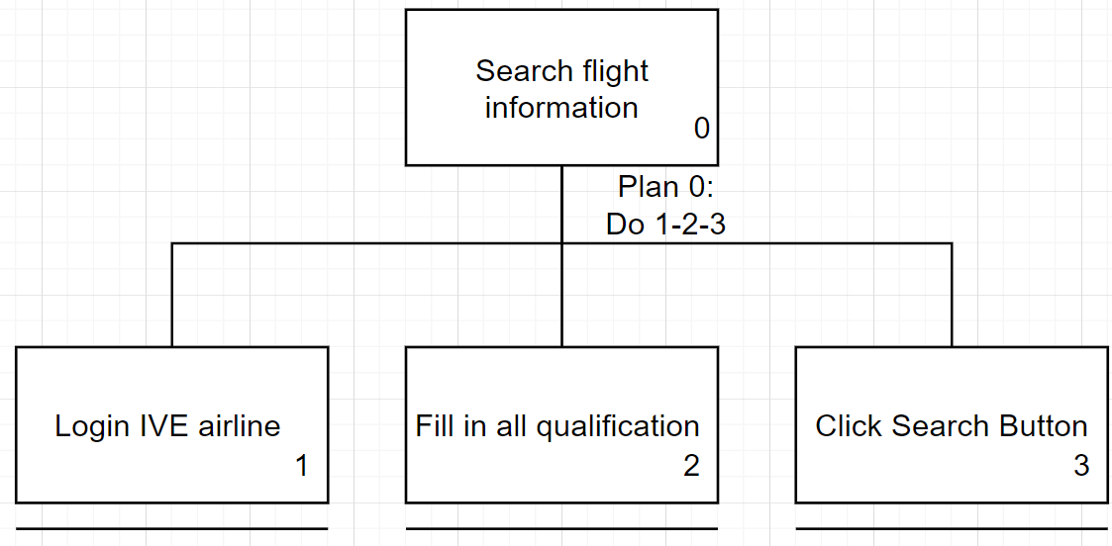

Make Booking

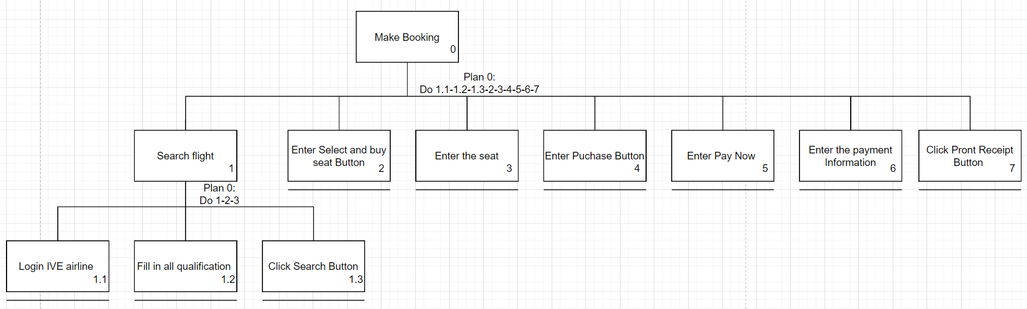

View Attraction

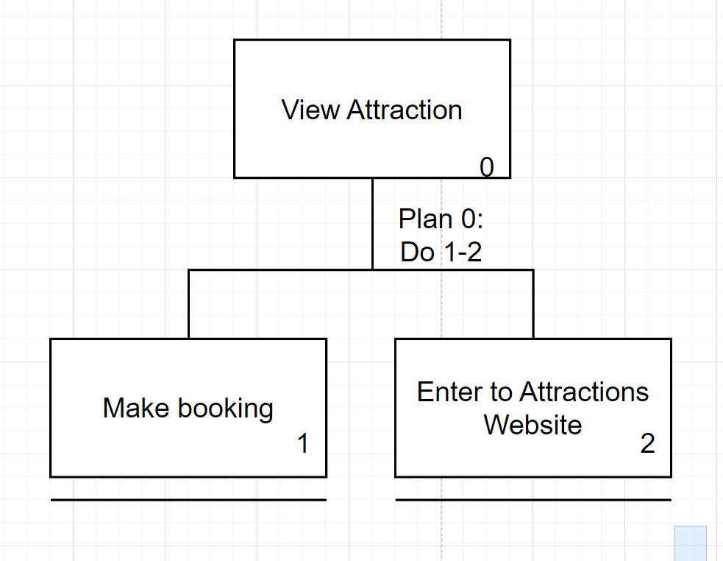

View Ticket

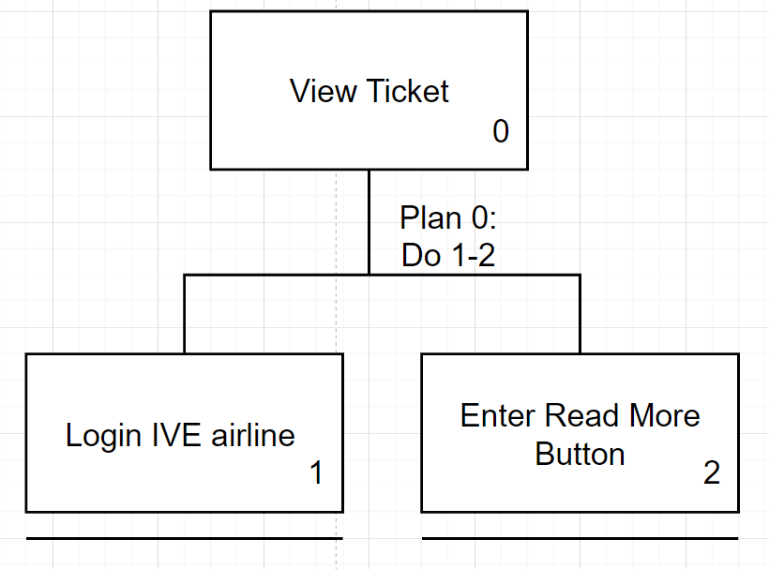

Refund Ticket

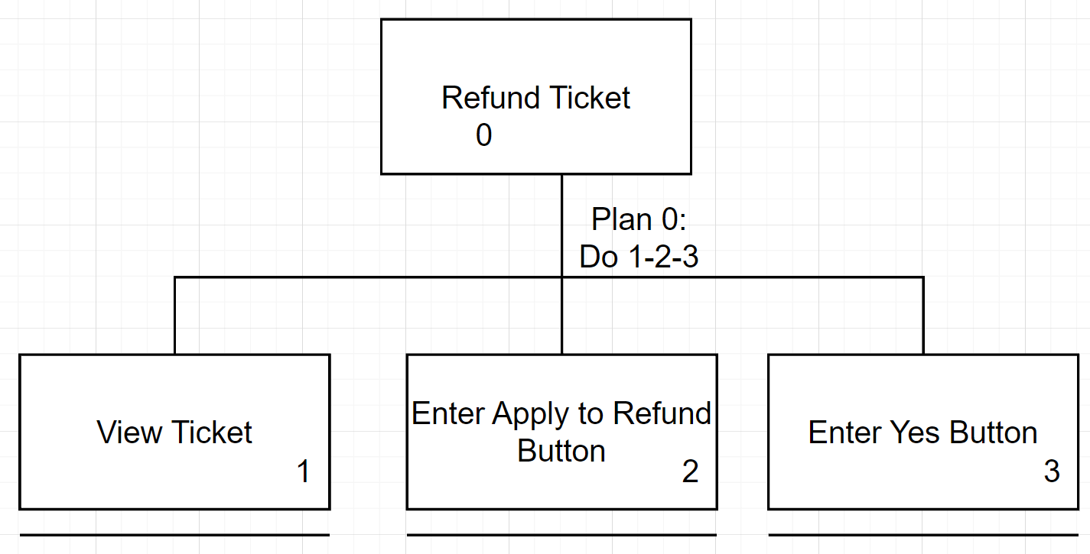

Change Ticket

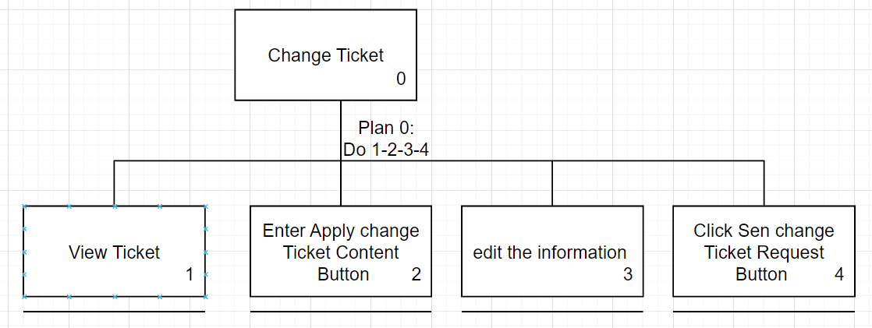

**Admin Task**

Add new Account

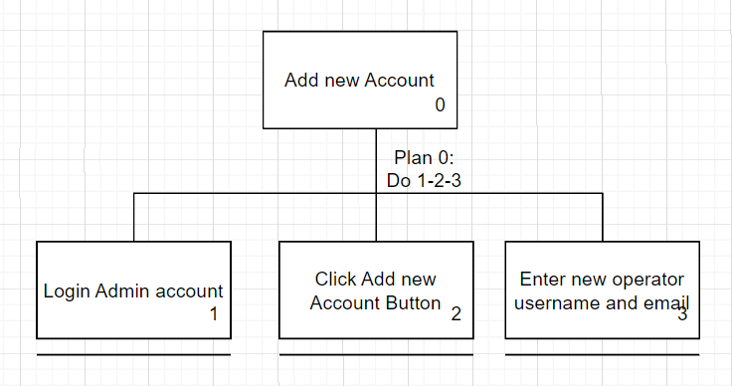

Send Email Request

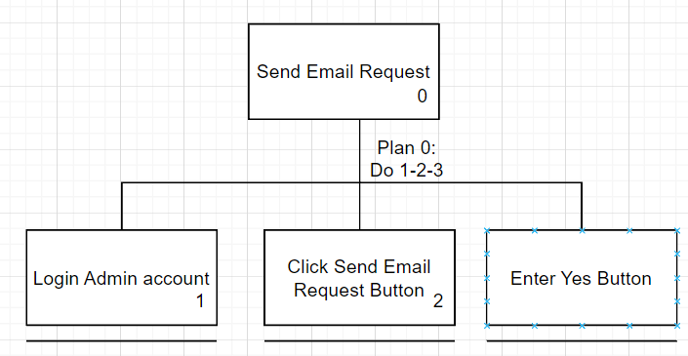

Delete Account

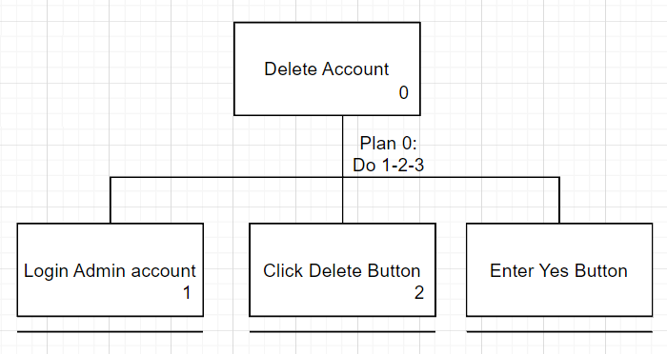

**Operator**

Edit Airline

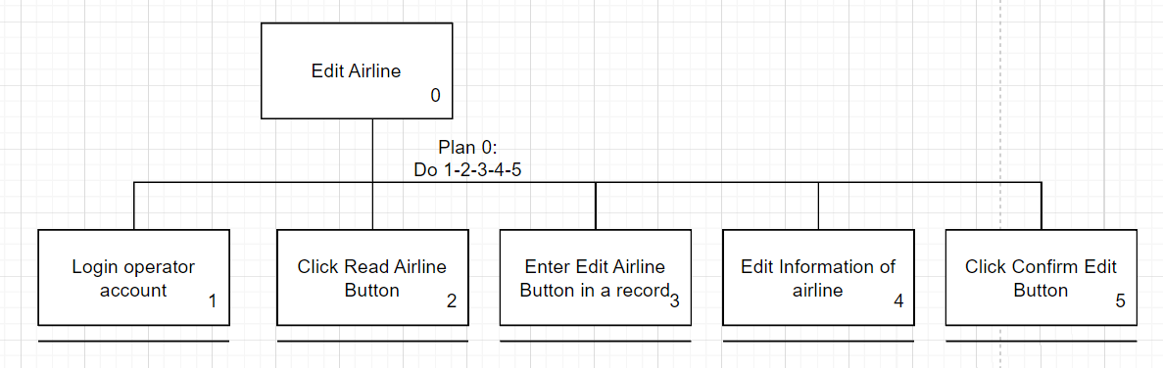

View Customer Ticket Request

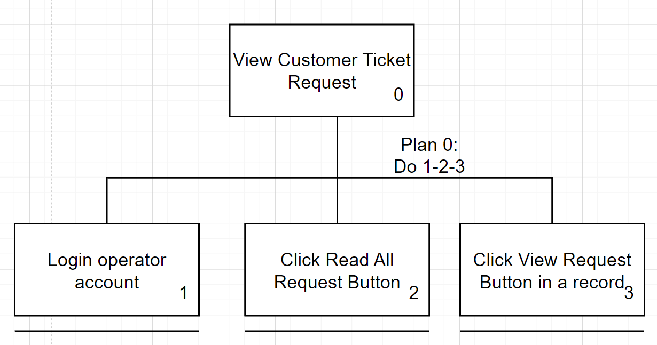

Accept Refund Request

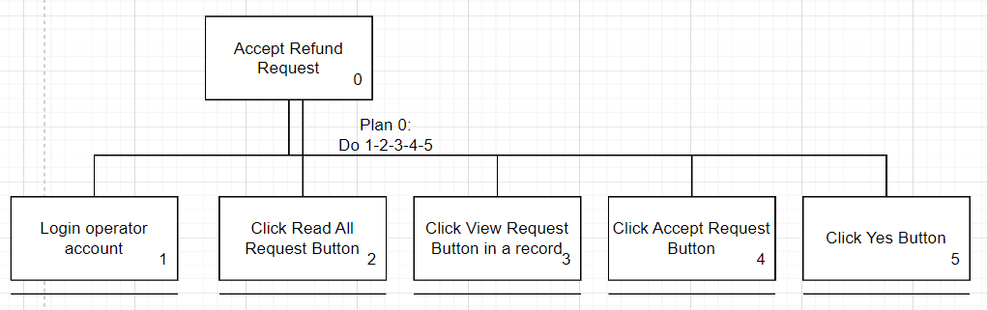

Reject The Request

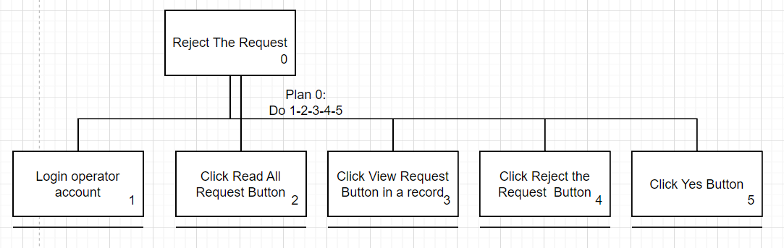

|  |  |
| --- | --- |
| Design Principles | Description |
| Mental Model | Scroll: move up and down |
| Affordance | 1.Register form of input box can be entering the personal  information.  2. Register form of button can be submitting the personal  information.  3. Login form of input box can be entering the login name and  password.  4. Login form of button can be login account |
| Content Organization | Body: Register form and Login form |
| Visual Organization | From of grouping the register / Login |
| Navigation | Global - Hyperlinks: menu bar (after sign in) |

Web Design Concepts

User Interface design

Home Page

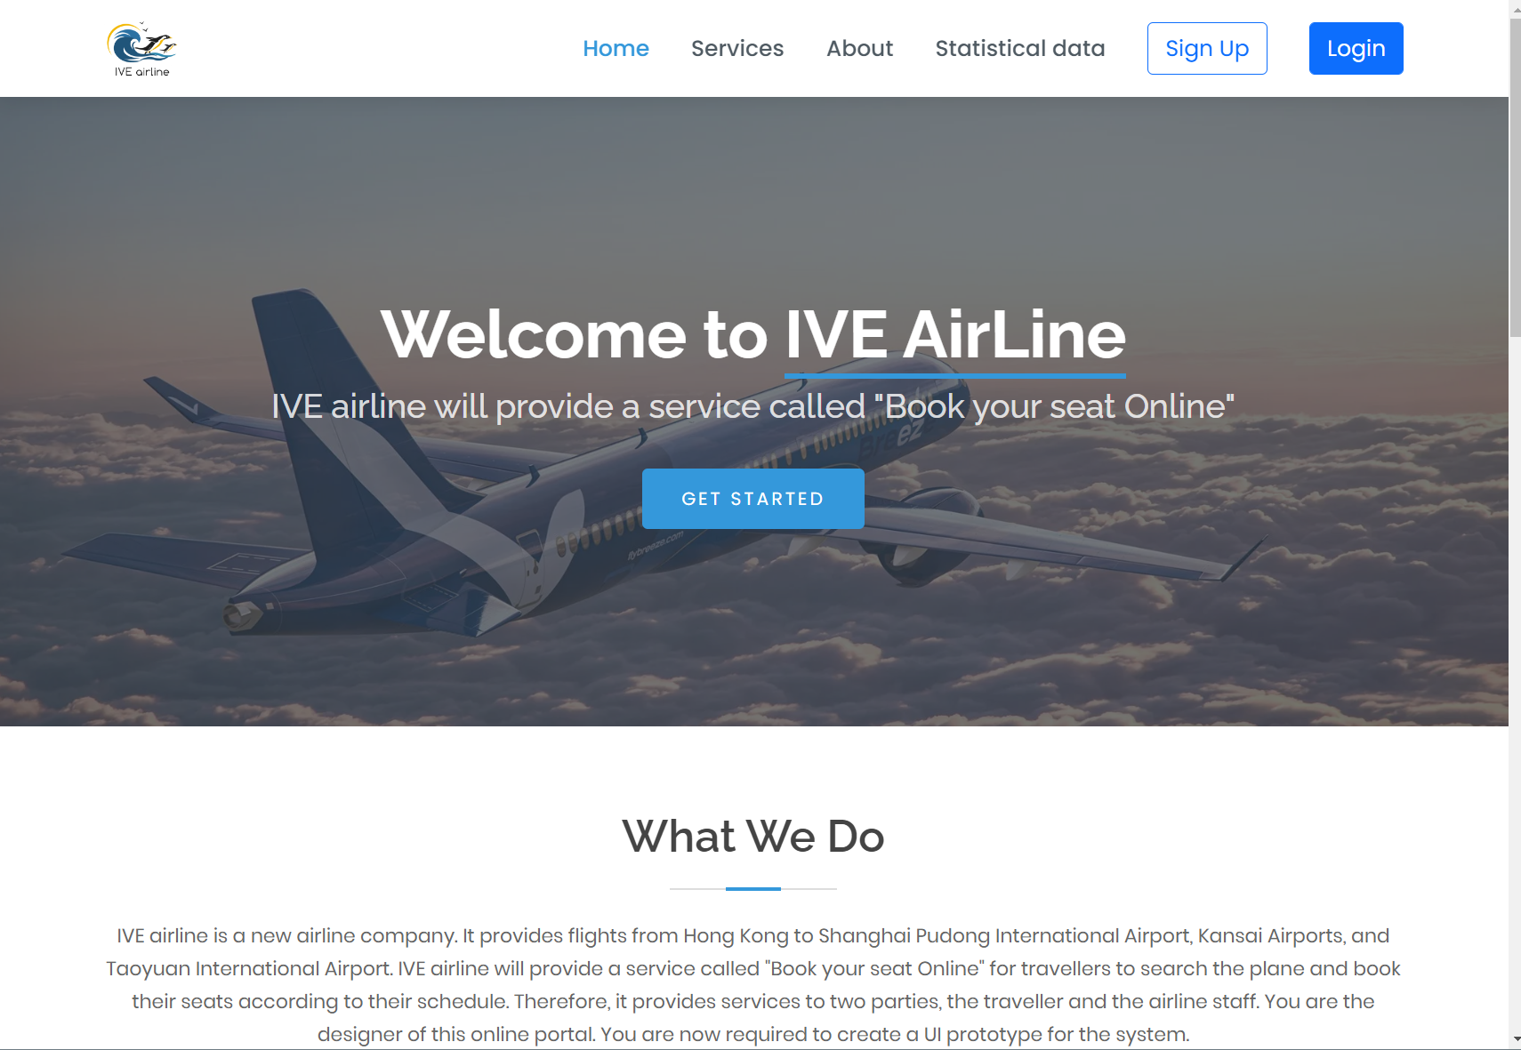

Register Page

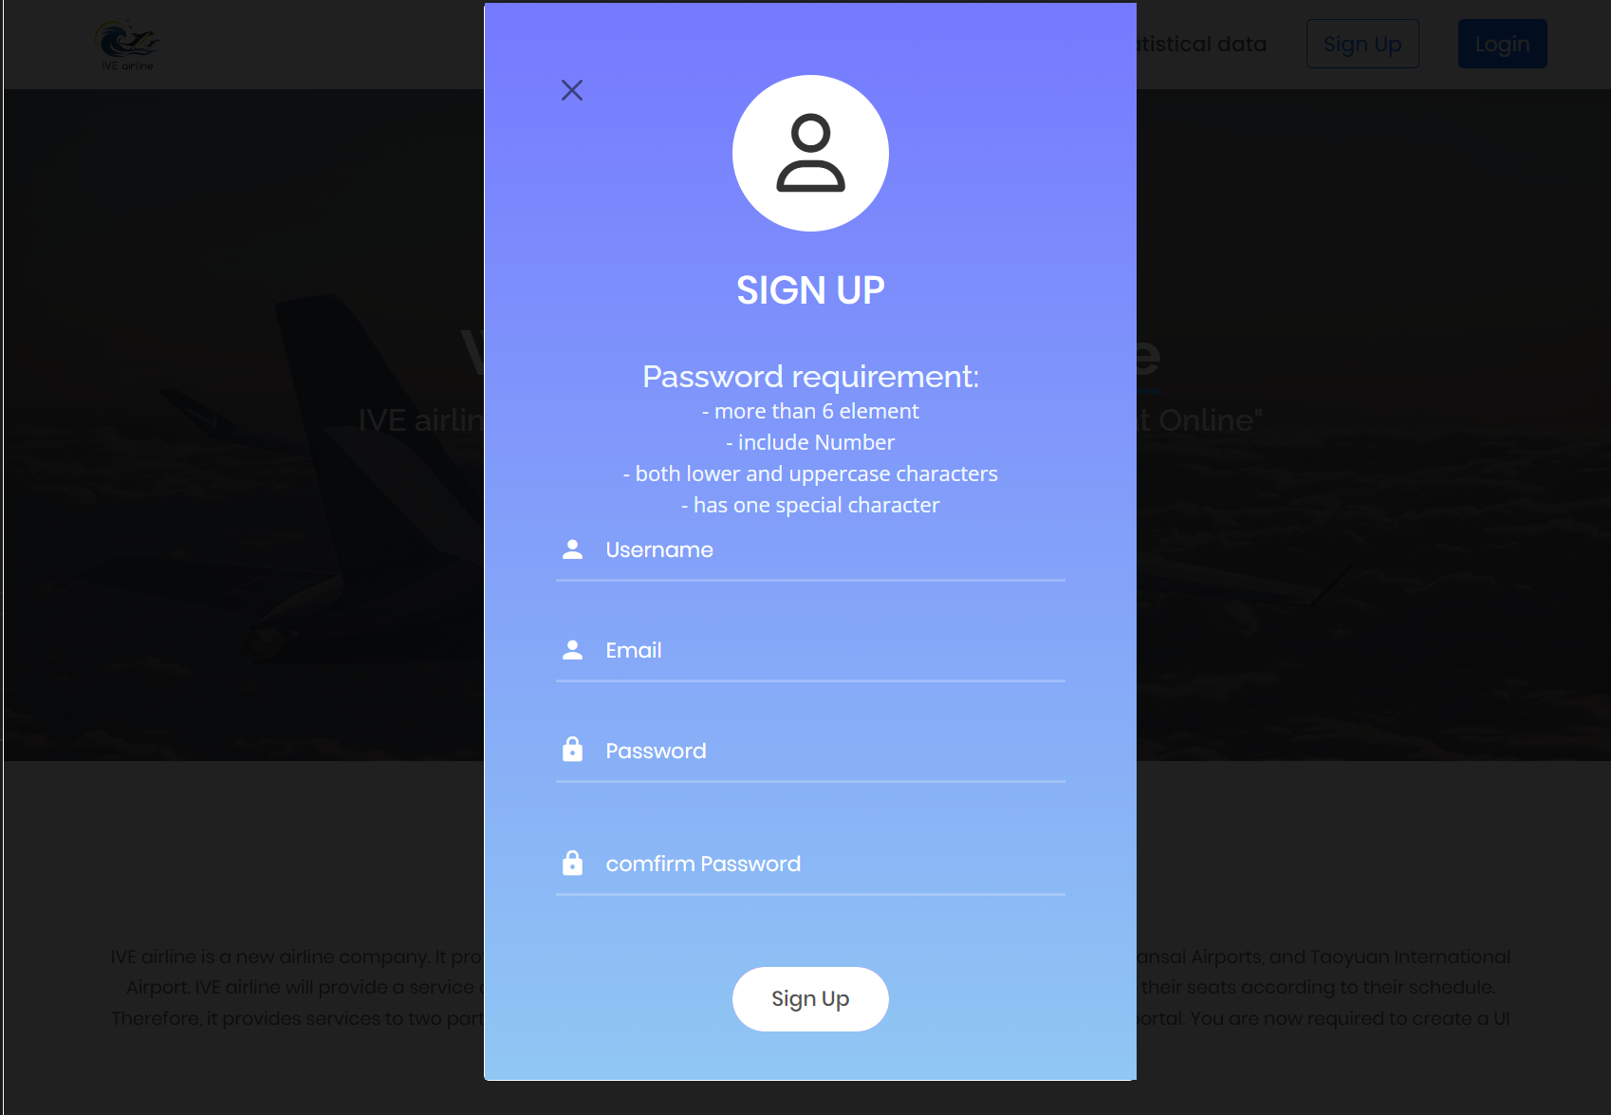

Login Page

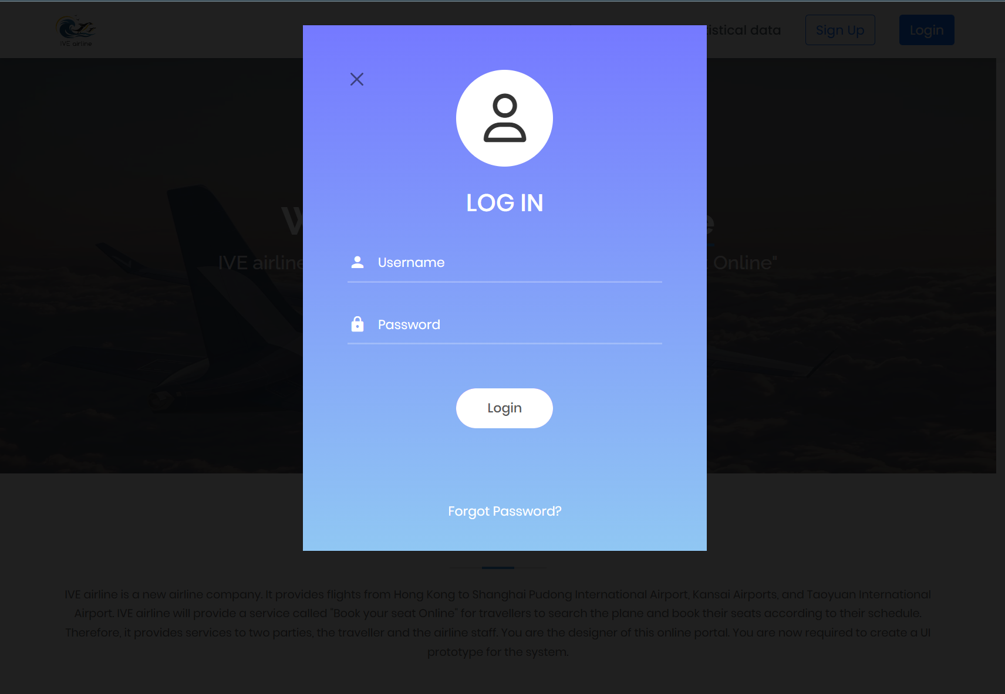

Search Flight

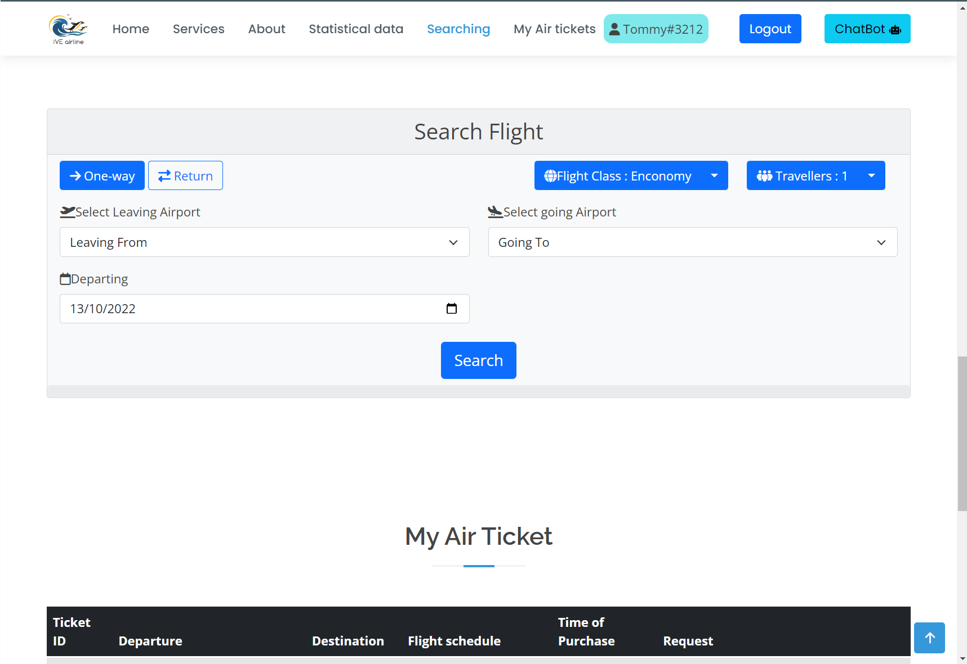

Result Flight

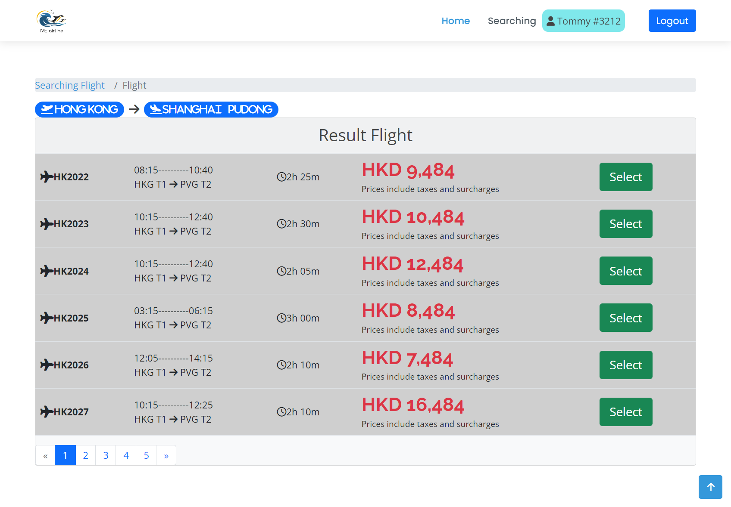

Purchasing Page

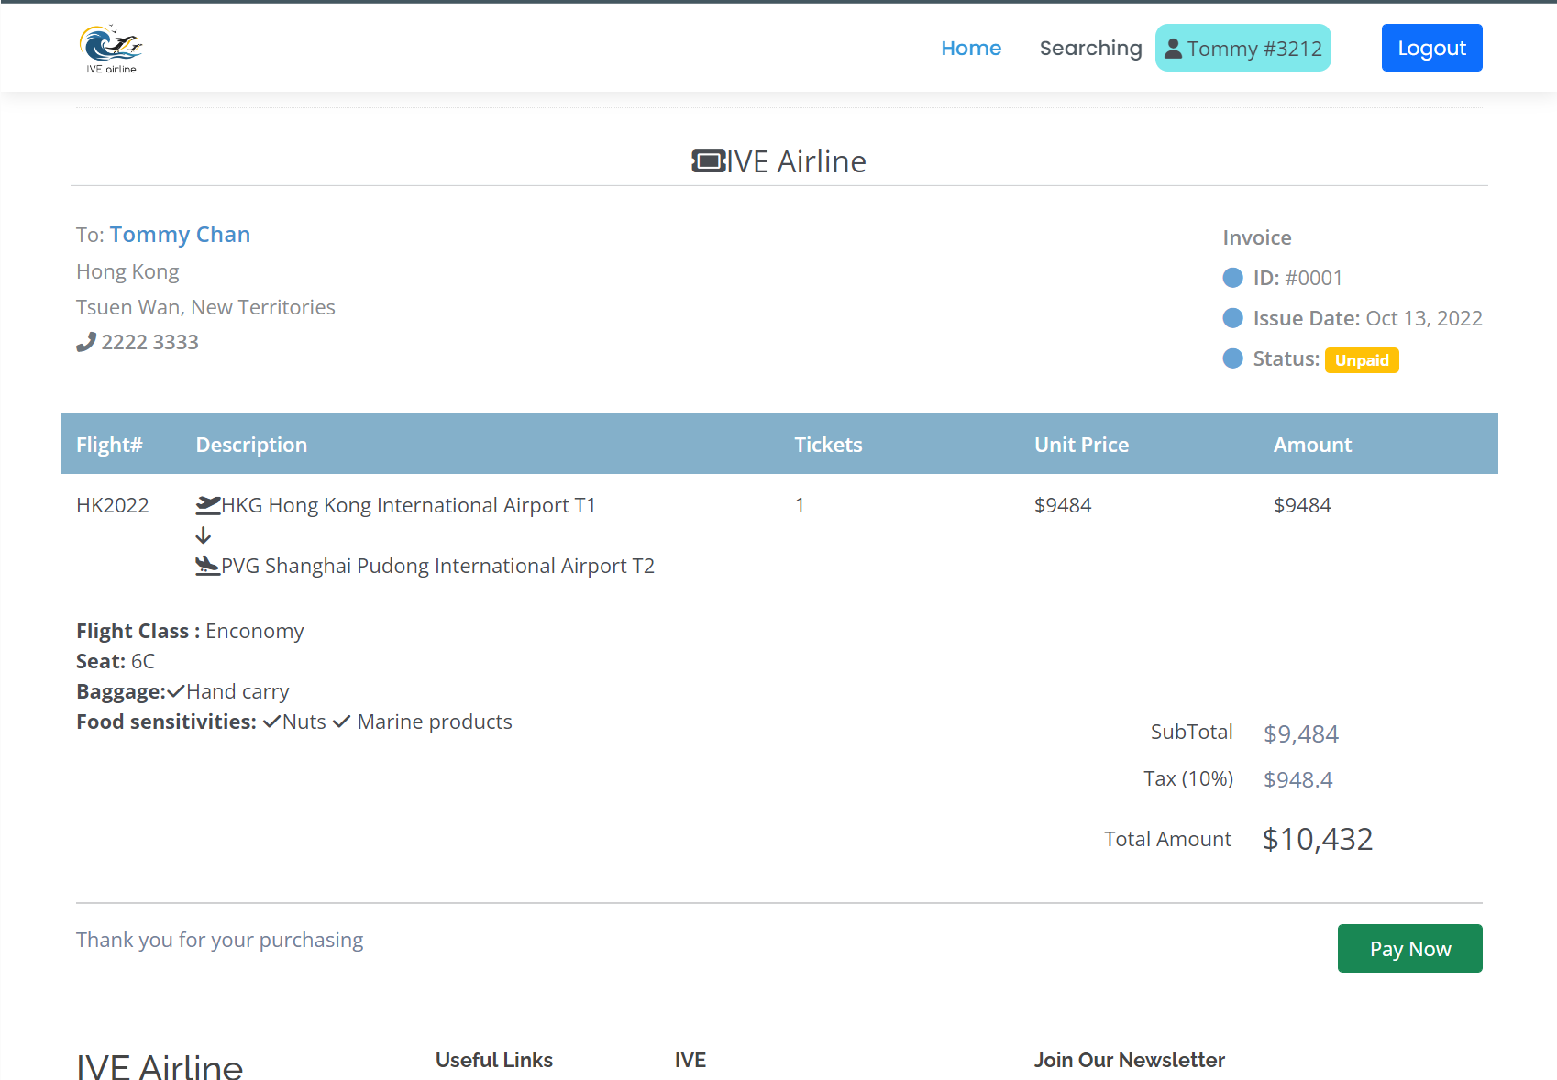

Payment Page

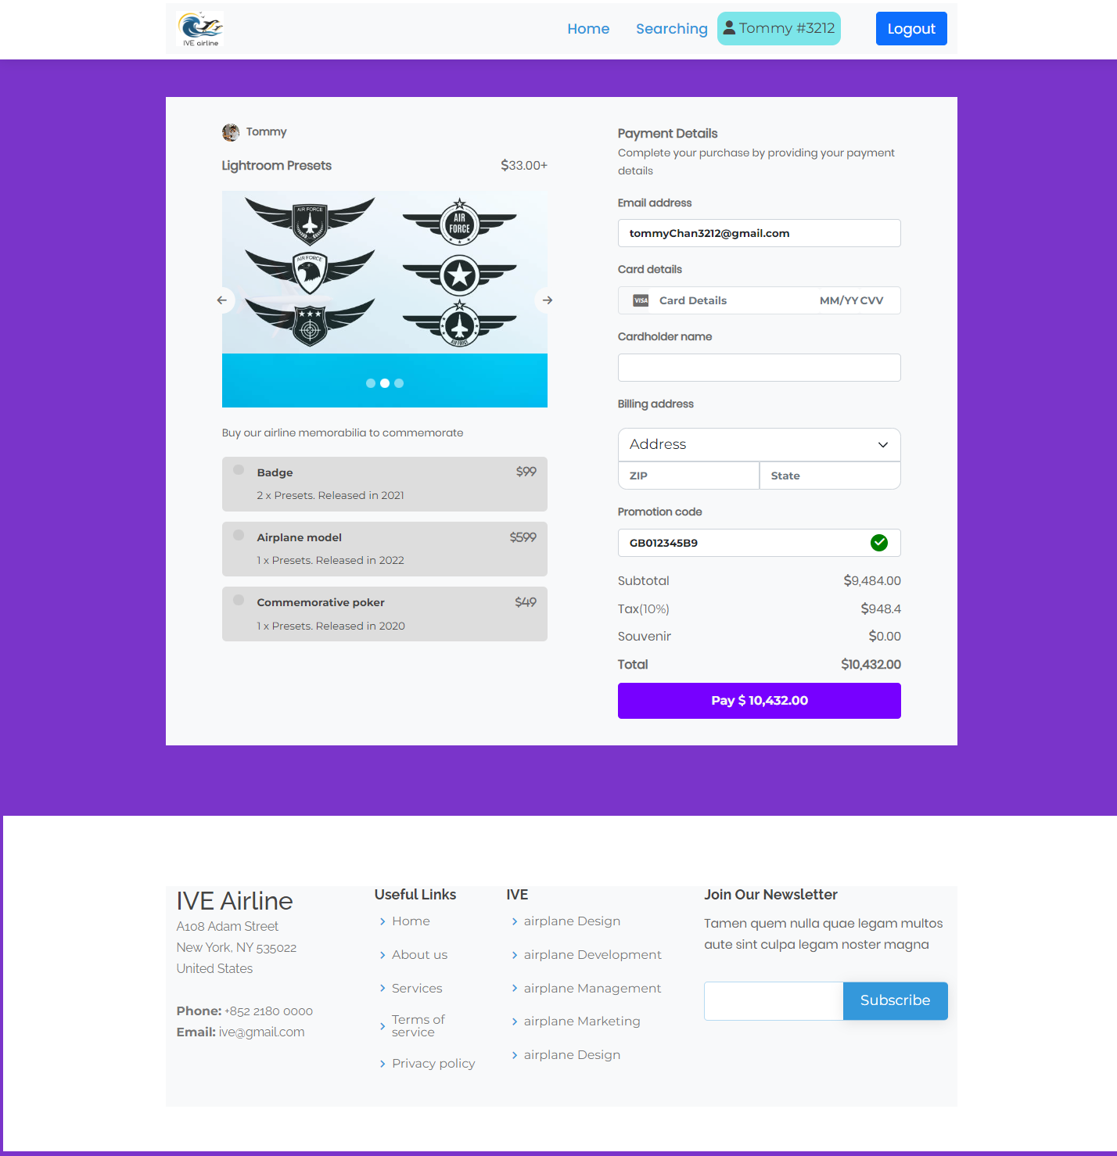

Attraction Page

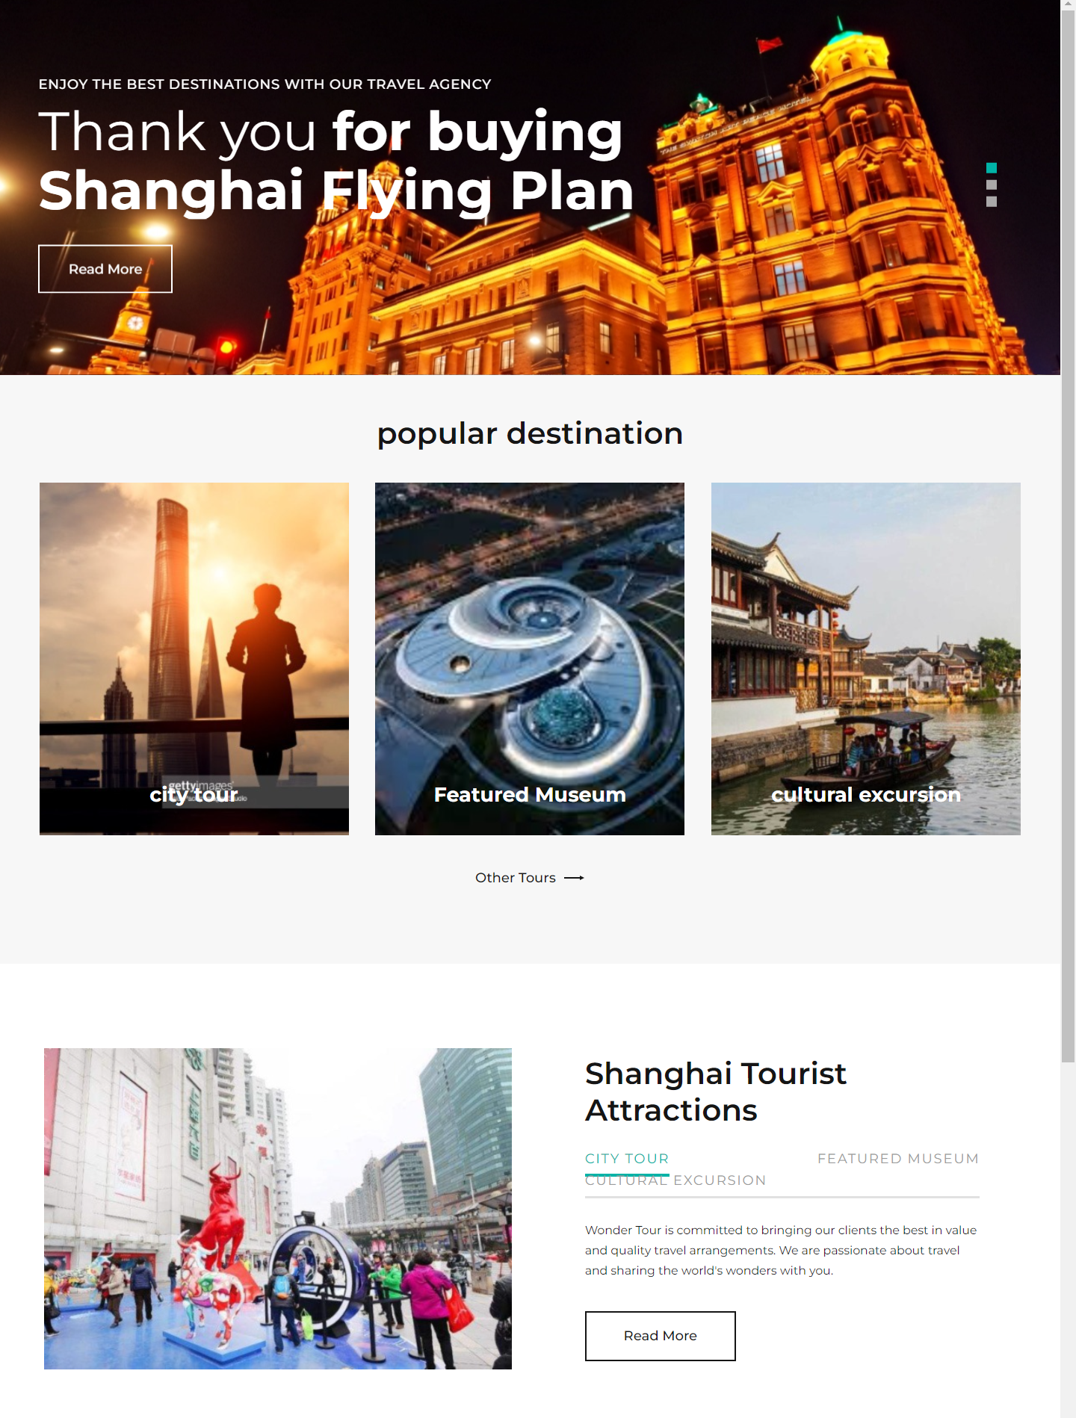

Recommend Hotel

View Ticket Page

